A Buffet of Stories
with
Sandy Schuman

Day, Date, Time
Place
Sandy Schuman is a storyteller, musician, and educator. He tells stories about songs and song-writers, personal adventures, historical sagas, folk tales, and stories in the Jewish storytelling tradition.

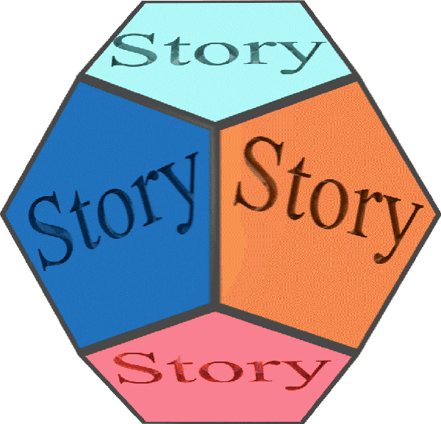  www.tothestory.com | Venue logo | Sponsor logo

